**Experiment No. -9**

**Aim -** Implement MapReduce example in MongoDB with suitable dataset.

1. Create a sample collection order with 10 documents.
2. Perform the map-reduce operation on the orders collection to group by the cust_id, and calculate the sum of the price for each cust_id.

**Software Required** - MongoDB

**Theory :-**

Map-reduce is a data processing paradigm for condensing large volumes of data into useful *aggregated* results. To perform map-reduce operations, MongoDB provides the mapReduce database command.

**Map-Reduce Syntax**

db.collection.mapReduce( function() {emit(key, value);},

//Define map function

function(key,values) {return reduceFunction}, {

//Define reduce function

out: collection,

query: document,

sort: document,

limit: number

}

)

**Map-Reduce Syntax Explanation** •

The above map-reduce function will query the collection, and then map the output documents to the emit key-value pairs.

After this, it is reduced based on the keys that have multiple values. Here, we have used the following functions and parameters.

• Map: – It is a JavaScript function. It is used to map a value with a key and produces a key-value pair

. • Reduce: – It is a JavaScript function. It is used to reduce or group together all the documents which have the same key.

• Out: – It is used to specify the location of the map-reduce query output

. • Query: – It is used to specify the optional selection criteria for selecting documents.

• Sort: – It is used to specify the optional sort criteria.

• Limit: – It is used to specify the optional maximum number of documents which are desired to be returned.

Consider the following map-reduce operation:

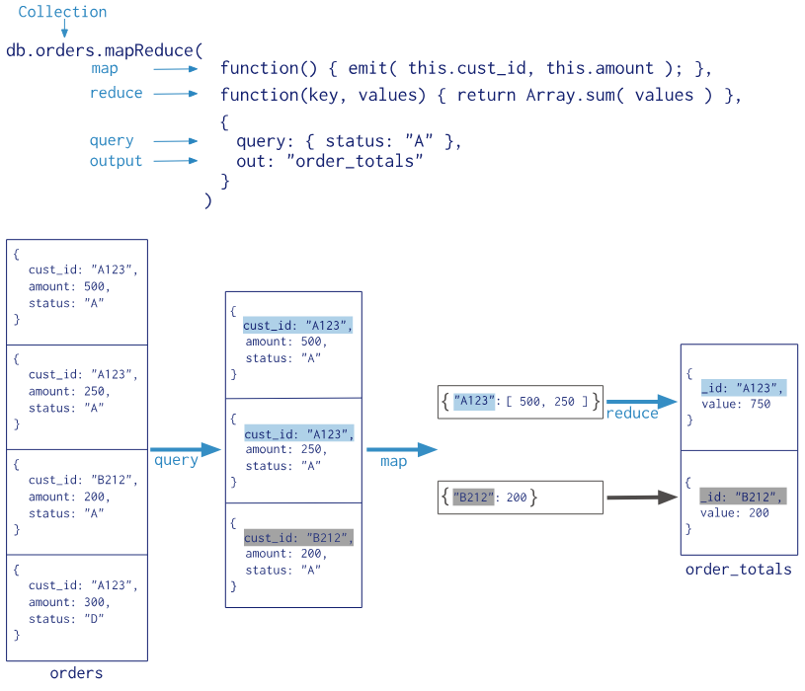

In this map-reduce operation, MongoDB applies the *map* phase to each input document (i.e. the documents in the collection that match the query condition). The map function emits key-value pairs. For those keys that have multiple values, MongoDB applies the *reduce* phase, which collects and condenses the aggregated data. MongoDB then stores the results in a collection. Optionally, the output of the reduce function may pass through a *finalize* function to further condense or process the results of the aggregation.

**Consider the following document structure that stores book details author wise.**

• > db.author.save({ "book_title" : "MongoDB Tutorial", "author_name" : "aparajita", "status" : "active", "publish_year": "2016" })

• > db.author.save({ "book_title" : "Software Testing Tutorial", "author_name" : "aparajita", "status" : "active", "publish_year": "2015" })

• > db.author.save({ "book_title" : "Node.js Tutorial", "author_name" : “Kritika", "status" : "active", "publish_year": "2016" })

• > db.author.save({ "book_title" : "PHP7 Tutorial", "author_name" : "aparajita", "status" : “passive", "publish_year": "2016" })

**Perform Below Tasks using Mapreduce**

1. To select all the active books
2. Group them together on the basis of author_name and Then count the number of books by each author

Let us consider school DB, where the student is a collection, and the collection contains documents, each of which includes a student’s name and the marks they received in a particular subject.

**Write the Mapreduce Program to Calculate the Total Marks Secured by each student in all Subjects**

Program: -

// Step 1: Create a sample 'students' collection with dummy data

db.students.insertMany([

  { name: "Alice", marks: { math: 85, science: 92, history: 78 } },

  { name: "Bob", marks: { math: 92, science: 88, history: 95 } },

  { name: "Charlie", marks: { math: 78, science: 86, history: 90 } }

]);

// Step 2: Define the Map and Reduce functions

var mapFunction = function () {

  for (var subject in this.marks) {

    emit(this.name, this.marks[subject]);

  }

};

var reduceFunction = function (name, marks) {

  return Array.sum(marks);

};

// Step 3: Run the MapReduce operation

db.students.mapReduce(

  mapFunction,

  reduceFunction,

  {

    out: "total_marks"  // Create a collection to store the results

  }

);

// Step 4: Query the 'total_marks' collection to see the results

db.total_marks.find();

// Step 5: Explain the MapReduce process

// - The map function emits the student's name as the key and each subject's marks as the value.

// - The reduce function sums up the marks for each student.

// - The results are stored in the 'total_marks' collection.

OUTPUT: -

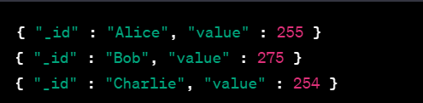

**Example of Document:**

db.students.find({}); { "_id" : ObjectId("5a1f9ce431c157f3ec2aec39"), "name" : "Midhu", "subject" : "science", "marks" : 68 } { "_id" : ObjectId("5a1f9ce431c157f3ec2aec3a"), "name" : "Midhu", "subject" : "maths", "marks" : 98 } { "_id" :

**Questions:**

1. MongoDB applies the _____ phase to each input document in mapreduce.
2. The map function emits —----------
3. MongoDB applies the _________ phase, which collects and condenses the aggregated data.
4. The output of the reduce function may pass through a ______ function to further condense or process the results of the aggregation.
5. _________ can return the results of a map-reduce operation as a document, or may write the results to collections.